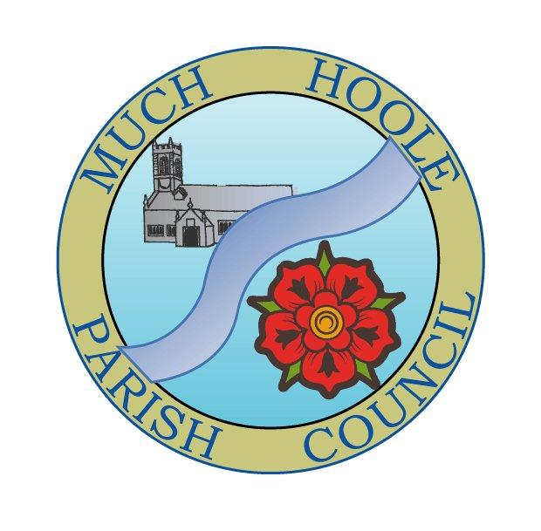 | MUCH HOOLE PARISH COUNCIL  NOTICE OF MEETING
You are hereby summoned to attend the Meeting of Much Hoole Parish Council to be held at 7.30pm on Monday 10th October 2022. The meeting will be held at the Venue (Hoole memorial village hall) Liverpool Road.
Russ Weaver, Clerk

AGENDA
1. | Apologies for Absence  To receive apologies for absence.
2. | Declaration of Interests and Dispensations  - To receive declarations of interest from Councillors on items on the agenda  - To receive written requests for dispensations for disclosable pecuniary interests (if any)  - To grant any requests for dispensation as appropriate
3. | Minutes of the Previous Meetings  To resolve to approve as a correct record the Minutes of the Council Meeting held on the 12th September 2022
4. | Public Time  To invite and listen to issues raised by members of the public.
5. | Reports from / invitations to other meetings  The Council will receive reports from meetings where Councillors have attended as representatives  An invitation is extended to a maximum of 2 Councillors to:  - The Town and Parish Councils conference (see agenda attached) 9.30am to 14.40pm (incl period for lunch)  - Followed by The LALC AGM (agenda awaited)  Both are to be held at County Hall on Saturday 12th November 2022  (Registration deadline 1st November)  - The next meeting of the LALC area committee will be held on Thursday 10th October 2022 at 7pm
6. | Off Road Cycle Track  To consider any updates on the Cycle track and resolve any actions required.
7. | Finance and Audit  To resolve to authorise payment of the following:  - To Resolve to pay the clerk in the sum of £480 (Aug and September pay)  - To resolve to pay HMRC £120 PAYE (August and September pay)  - To resolve to pay PKF LITTLEJOHN in sum of £360 for external audit services  - To resolve to pay Lengthsman Gary McKenna in sum of £899.25 re invoice 116 (covering all work from April to September) This includes £56.79 of reclaimable VAT for materials which he has bought on behalf of the Council and is claimimg re-imbursement.  - To receive and note the external audit report. (Copies of this report and all audit material are displayed for public access on the website and the notice boards.)
8. | Community Projects update  To receive an update on any ongoing projects  - Village signage. The signs are being manufactured and delivery is awaited.  - Following comments at the last meeting during public time, concerning the general appearance of the village, footpaths and hedges, a walking survey has been completed.  .
9. | Car Parking  Due to the absence of the Clerk due to illness, there has been no progress regarding liaison with LCC to increase roadside parking space around the recreation ground. However, enquiries to improve parking will continue.
10. | Planning  There are no planning applications relevant to Much Hoole
11. | Village Hall development update  To receive and note a report on the progress of The Venue. A progress report is presented in recognition that the Parish Council has provided financial support to its development.
12. | Footpaths  To receive an update on any public footpath repair or maintenance issues
13. | Training  LALC is organizing a free (to members) training session on getting the best use of MARIO mapping, presented by the senior ICT and digital service manager from LCC who own the system. The training will be via Zoom and will last approximately 1 hour at 7pm Thursday 13th October 2022  Councillors and Clerks are invited to register for the event (via the clerk)
14. | Grants  No new grant applications have been received
15. | Newsletter  The Council is asked to note the draft items suggested for a newsletter and suggest topics and any other items and material for inclusion in the next newsletter
16. | Items for next agenda
17. | Date of Next Meeting  The Parish Council to agree the date of the next meeting as 7.30pm Monday 14th November 2022, to be held at ‘The Venue’, Liverpool Road, Much Hoole.

